Purpose

This Visual Job Aid will instruct the Subawards GCO on how to prepare Unilateral and Bilateral subaward agreements for signature.

Scope

- Unilateral Subaward Modification Agreements
- Bilateral Subaward Modification Agreements
- Initial Subaward Agreements (Bilateral)

Definitions

Terms unique to this process or procedure

Subaward agreement: Agreement between ASU and a Subrecipient, where ASU is the Pass-Through Entity (PTE)

Unilateral agreement: Agreement which only needs to be signed by ASU

Bilateral agreement: Agreement which needs to be signed by both the Subrecipient and ASU

Responsibilities

- Subawards GCO prepares subaward agreements for signature by someone who has signature authority (Authorized Official)
- Authorized Officials may include the Assistant Director, Associate Director, or Executive Director

Requirements / Steps

- Seek PI approval first for both Unilateral and Bilateral agreements

- Upload PI approval to task on “Finalize Subaward Task Request” page by either selecting “+Add” or drag-and-drop email

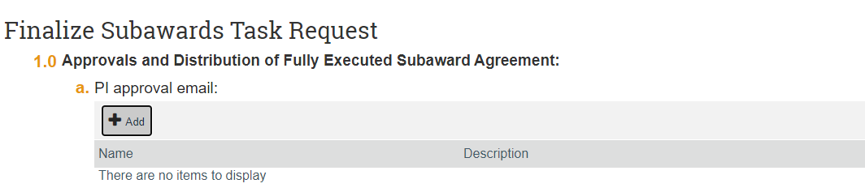

Unilateral Subagreement
- Add name and title of Authorized Official and date to agreement
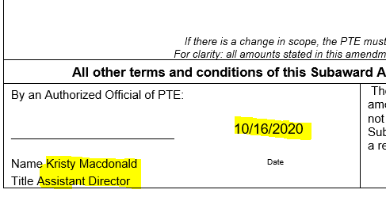
- Compose Email to Authorized Official, including the link to the task ID and Subrecipient name
- Attach agreement and send to Authorized Official

Bilateral Subagreement (Initial Agreements and Bilateral Modifications)

- Partially Execute the Agreement by sending the agreement to the Subrecipient for signature
- Select “Email” from the My Current Actions list in ERA task
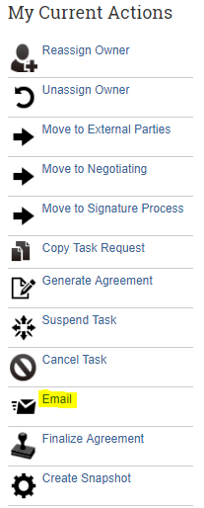
- Select the Subrecipient POC Email as the To address and Copy the GCO Agreement Reviewer and the RA

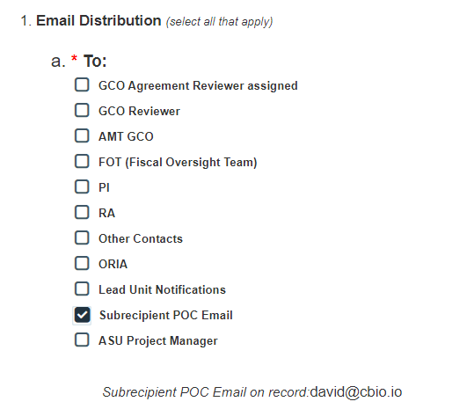
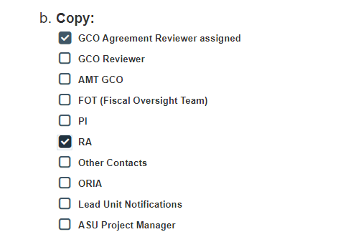
- Select “REQUIRES ACTION” under 2. Subject Line, a. Prefix wording
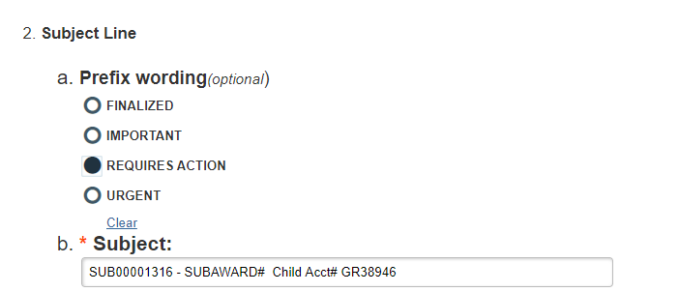
- Select “For External Review/Signature” under 3. Email Body

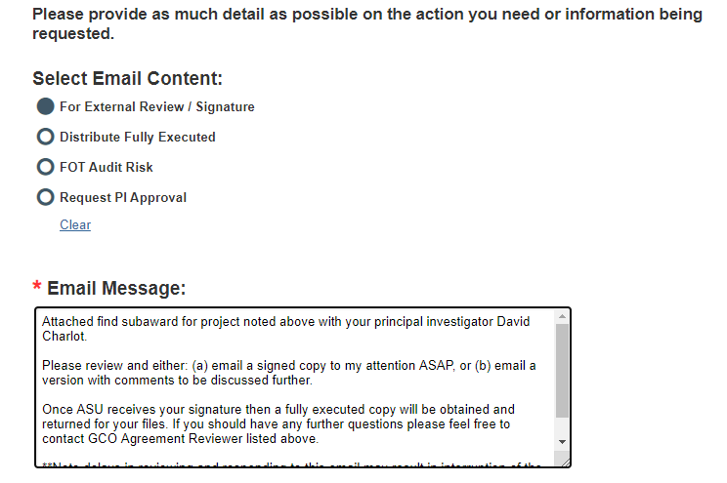
- Attach agreement to Section 4. by either selecting “+Add” or drag-and-drop document

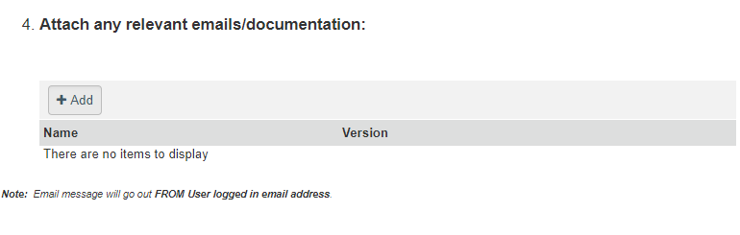
- Select “OK” to send Email to Subrecipient with attached agreement for review/signature

- Follow up with Subrecipient every 5 business days to obtain a partially executed agreement from the subrecipient

- Add name of Authorized Official and date to partially executed agreement once it has been received from Subrecipient
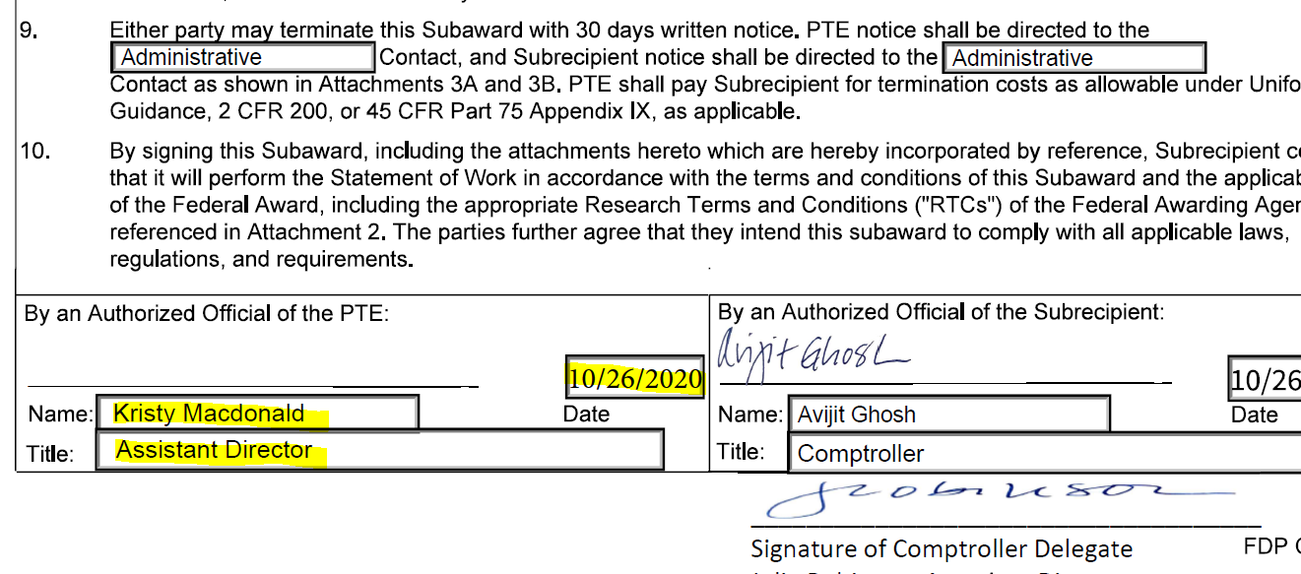

- Compose Email to Authorized Official, including the link to the task ID and Subrecipient name

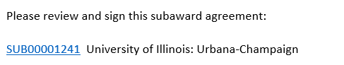
- Attach agreement and send Email to Authorized Official

