RAs can now view the status of agreements / contracts and subawards tasks via ERA Agreements.

Here is an easy way to search for such tasks.

- Within ERA, navigate to ERA Agreements.

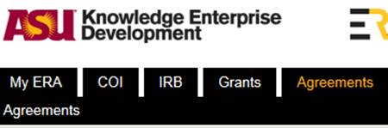

- Click on the “All” tab.

- From the “Filter by” drop-down, select FP ID, Sponsor, or PI (Last).

- Enter the number or name and click on “Go”.

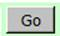

All Agreements related to your filter criteria in every stage of the process, including completed, will appear.

Note: You can further filter by clicking “Advanced” to enter additional search criteria.

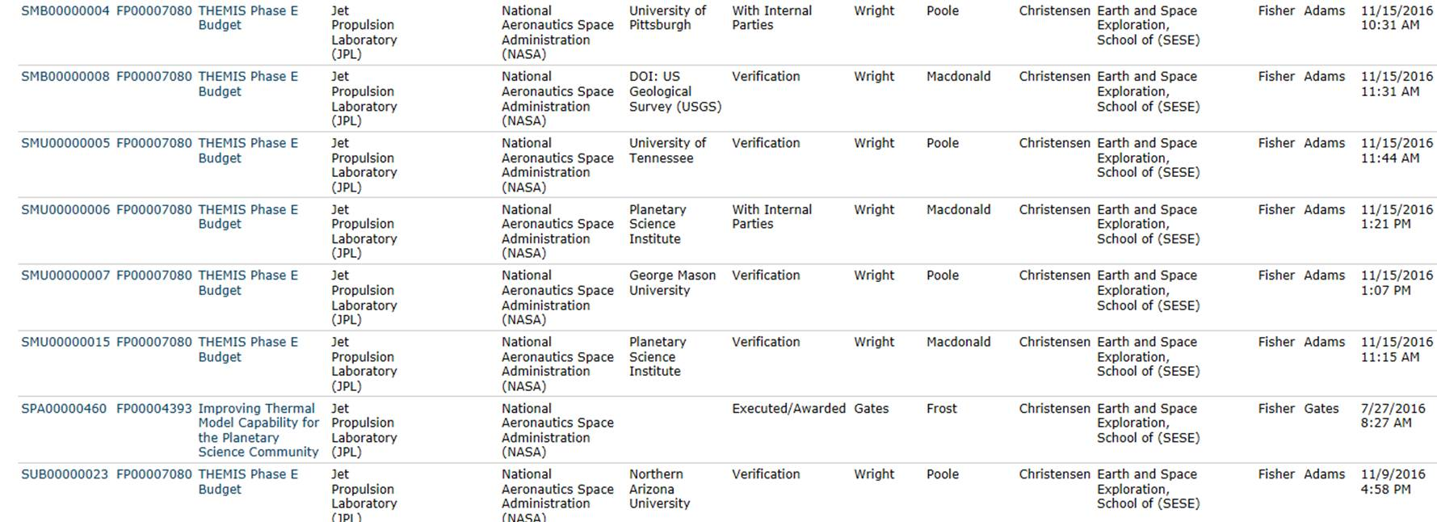

- Click on the appropriate “Task ID” and review the comments under “Brief Task Status”.

These notes will allow you view the current status.
