CITI Training Instructions
- Go to CITI Program website at https://citiprogram.org
- Select "Log in”
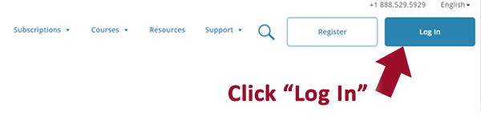
- Choose “LOG IN THROUGH MY INSTITUTION”
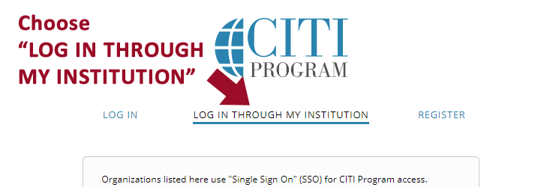
- Select "Arizona State University" under the list of organization names
- Log in using your ASURITE ID and Password
- After logging in, select “I don’t have a CITI Program account” unless you already have a CITI account or had a CITI account through another institution
- Follow the on-screen instructions
- After logging in, roll out the “Arizona State University Courses” tab
- This screen will allow you to begin a new course, continue a course you’ve started, and lists any courses you have completed
- To add a course, select “Add a Course”
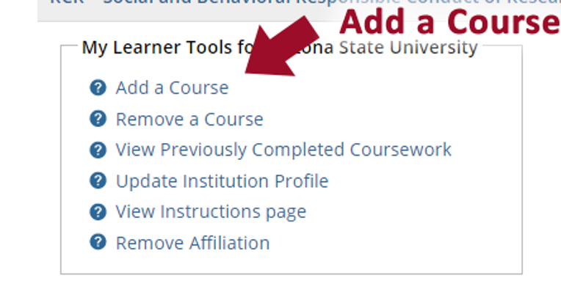
- Click "Add a Course or Update Learner Groups" to select the Undue Foreign Influence: Risks and Mitigations course.
- Take the training following the program prompts
- After completing the training, complete your profile by clicking "My Profiles" across the top.
- Select the "Arizona State University Profile" blue bar and fill out all open fields. IMPORTANT: When filling out the section titled "ASURITE (ex: jdoe)," make sure to fill it out in all lowercase, as the CITI website is case sensitive. Your ASURITE in CITI is what communicates with the ASU system to clear your RCR requirement from MyASU.

